THE ROAD TO SUCCESS
Getting Where You Need to Be
As a Community, we understand that sometimes it is challenging to travel to work, home, or even to be there for your family while caring for others. We want to help you find solutions, so that you can focus on providing Quality Care, and know that everything is okay.
Collaborative & Child Ride Sharing
As a team, it is important to work together.
Engage with your community to find
other parents to coordinate childcare pick up & drop off.
Work with your Facility to see if there are personnel available to ride share in close proximity to your home.
Connect with WayToGo to reconsider the way you commute.
Zip Car
A resource available in Colorado – Aurora, Boulder, Breckenridge, Colorado Springs, Denver, Fort Collins, Golden, Greenwood Village Monthly $7/month INDIVIDUAL rate - Driving rates from $10/hr and
$83/day.
Membership includes:
- Secondary insurance for all trips
- Free gas for all trips
- Maintenance and 24/7 roadside assistance
- 180 miles per day ($0.58 per mile after that) Business accounts are
available.
Transportation Information
CDOT
LYFT
Uber
Metro Taxi

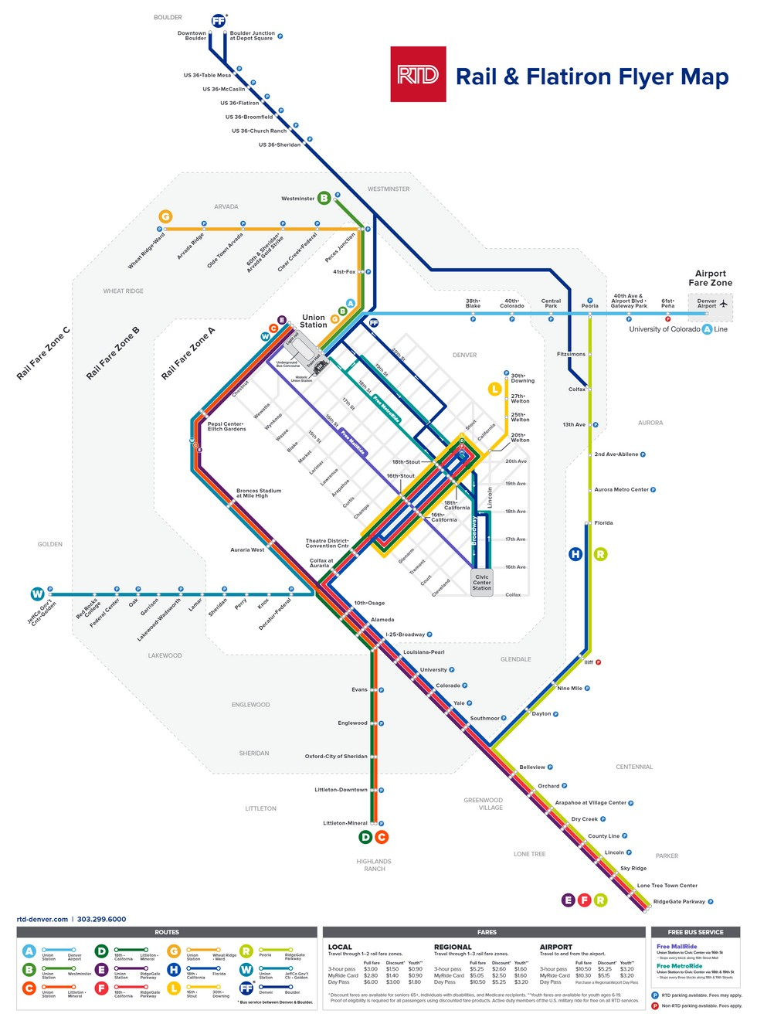
REGIONAL (RTD) TRANSPORTATION DISTRICT

Bus Schedules Rail Schedules

Skyride Schedules

