Welcome to Our Community
C O L O R A D O H E A L T H C A R E A S S O C I A T I O N

Welcome, Jenny, and thank you for choosing the Colorado Health Care Association as your next work home. You are one of us now, and we couldn't be more proud to have you as part of our team.

Community Engagement

FACILITY
INFORMATION

As a member of CHCA, we encourage you to participate in Community Events.
Please look over the CHCA Event Calendar for upcoming engagements.
CHCA values your insight, please consider joining one of our Committees and making a difference in our Community.
If you have any questions, please connect with our Senior Executive Assistant; Colleen Olsen.
Colorado Health Care Association 4100 E. Mississippi Ave, Suite 925
Glendale, CO 80246
Phone Number: (303) 861-8228 Website: Cohca.org
CHCA Conversations Blog Username: ColoHealthCare Password: CoHcA
Connect @ CHCACCAL

CHCA Contacts
President C CEO: Doug Farmer
Director of Quality C Regulatory Affairs: Jenny Albertson
VP of Operations: Bonita Jones
Director of Finance: Josh Fant
Senior Executive Assistant: Colleen Olsen Executive Administrative Assistant: Robin Murp hy

COMMUNITY INFORMATION

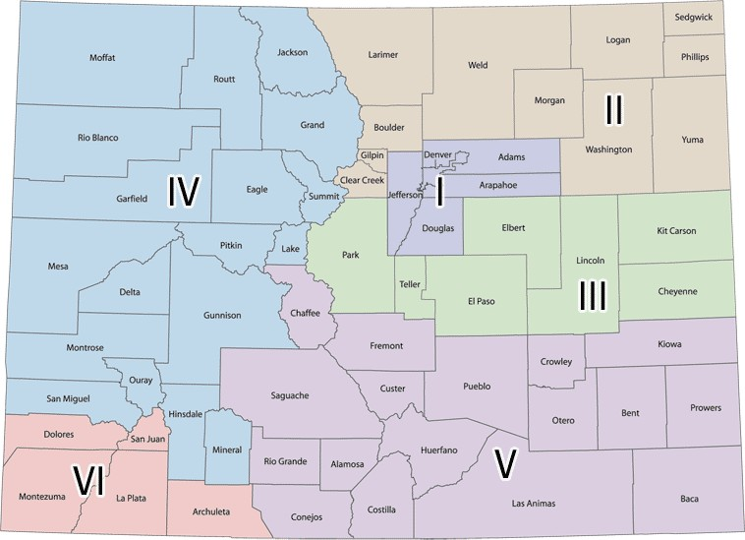

Community Handbook

Community Benefits

Holidays

Careers Fields

All full-time personnel for CHCA are entitled to:

Vacation PTO
Health Insurance Vision/Dental Insurance
401k
New Year’s Day Memorial Day Independence Day
Labor Day Veterans Day Thanksgiving Day Christmas Day
Administrative Nursing Activities Social Services Environmental Services Career Ladder

COMMUNITY RESOURCES

Recreational Activities

Retail C Dining

Community Outreach

Creekside Park Infinity Park Cherry Creek Art Festival
Planet Fitness Bowlero
AMC Theater
Mings Dynasty Caitlin's PokeCity Smashburger Pizza Hut
King Soopers Target Sprouts

Local Schools

Childcare
Colorado Department of Human Services Child Abuse and Neglect Hotline
State Benefits Assistance Department of Motor Vehicles
Tax Filing Education – Colorado
Tax Filing Information
– Federal

Transportation

Holly Elementary McMeen Elementary West Middle School Cherry Creek High School
Boys & Girls Club YMCA
ECS
Augustana Early Learning Center Ganeinu Lifetime Kids Camp

RTD
Uber Lyft
HopSkipDrive

