How to create an account
- Go to this website: https://educate.ahcancal.org/
- Click on Create Account (Yellow Button)
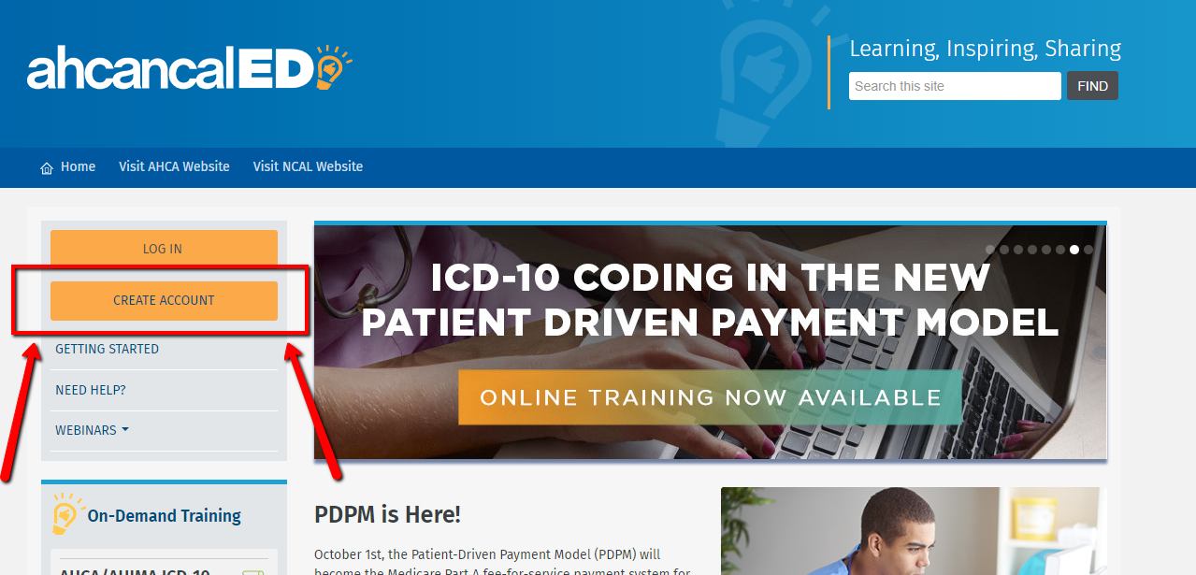
- You will then come to this page:
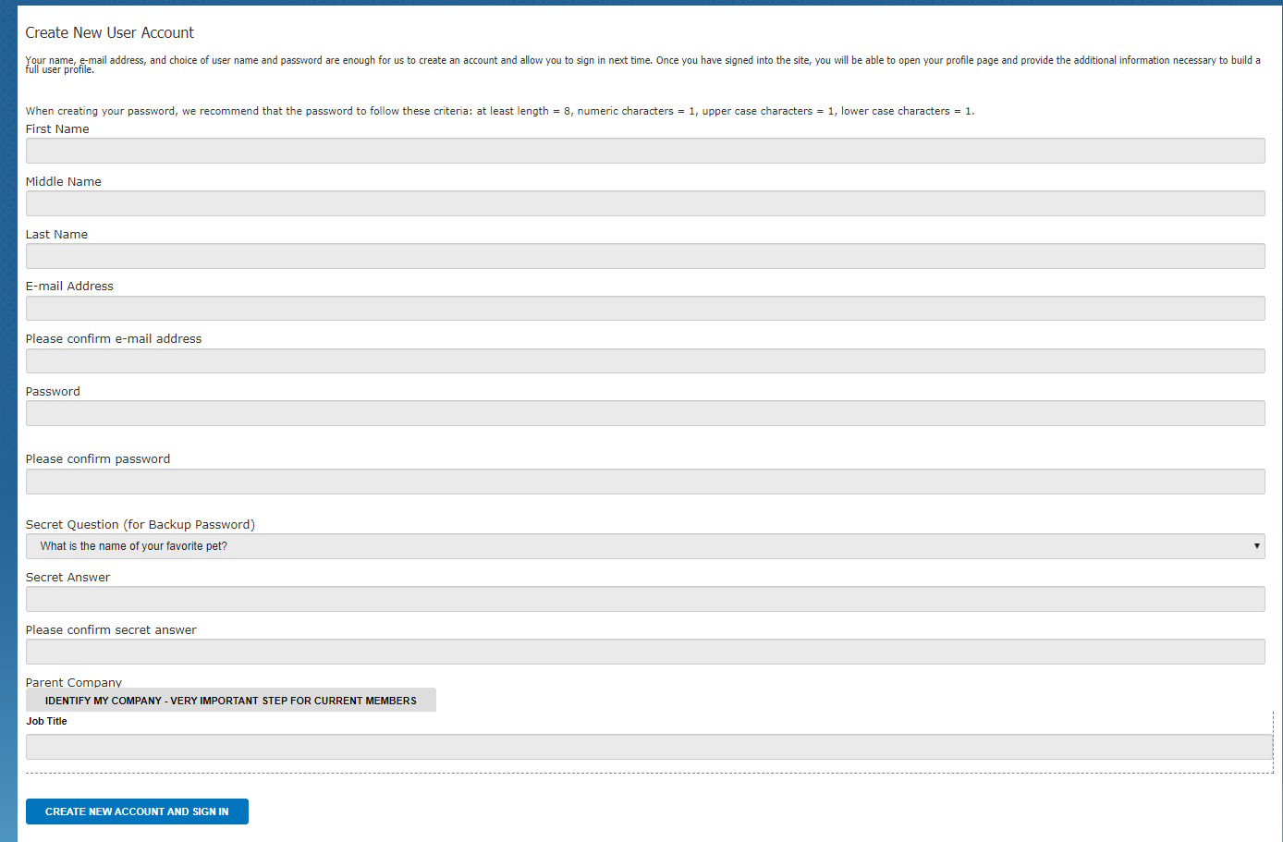
- Please fill out all of the information on the Create New User Account Page
- Once you get to Parent company, please click on “Identify my company” and a box will pop up
  - please note if you cannot find your company by Account name please search by zip code
  - do not fill in all lines, just one line (account name ONLY and search OR zip code ONLY and search)
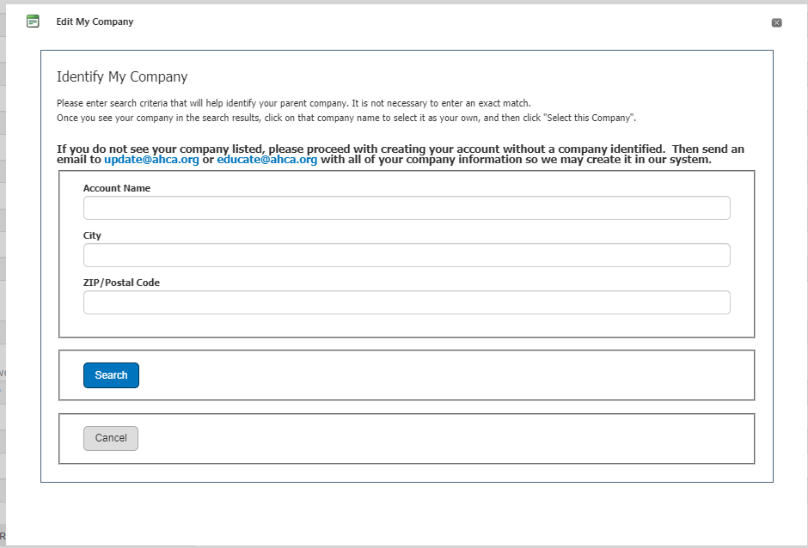
- Once you have filled out all the information and have added your company to your profile, please click “Create new account and sign in”
If you are having any trouble, please email educate@ahca.org

